**Abstract:**

Renewable energy sources have emerged as the future of the energy industry due to the adverse environmental impacts associated with conventional energy sources. However, integrating renewable energy into the grid poses challenges due to the unpredictable and variable nature of these sources. To address this challenge, accurate forecasting of renewable energy output is essential.

In this study, we focus on the power output prediction of Photovoltaic (PV) plants, a significant renewable energy source. Traditional methods require various input data, such as historical weather data, weather forecasts, and historical PV data. However, obtaining accurate data is a challenge in Nigeria, necessitating the development of a model that relies on readily available data.

We propose a model that utilizes only historical PV power output data, which can be easily measured for any PV plant. Renewable energy sources have emerged as the future of the energy industry due to the adverse environmental impacts associated with conventional energy sources. However, integrating renewable energy into the grid poses challenges due to the unpredictable and variable nature of these sources. To address this challenge, accurate forecasting of renewable energy output is essential.

In this study, we focus on the power output prediction of Photovoltaic (PV) plants, a significant renewable energy source. Traditional methods require various input data, such as historical weather data, weather forecasts, and historical PV data. However, obtaining accurate data is a challenge in Nigeria, necessitating the development of a model that relies on readily available data.

We propose a model that utilizes only historical PV power output data, which can be easily measured for any PV plant. Through feature extraction techniques, we extract relevant features from the data, including timestamp features and aggregated PV output for the same time across different years. These features are then used as inputs to train a Long Short-Term Memory (LSTM) algorithm.

Our results demonstrate the superior accuracy of the LSTM algorithm compared to Artificial Neural Networks (ANN) and other reference techniques in predicting the power output of PV plants. This research highlights the effectiveness of utilizing readily available data and employing advanced deep learning techniques for accurate power output forecasting, thus enabling the seamless integration of renewable energy into the grid.

These features are then used as inputs to train a Long Short-Term Memory (LSTM) algorithm.

Our results demonstrate the superior accuracy of the LSTM algorithm compared to Artificial Neural Networks (ANN) and other reference techniques in predicting the power output of PV plants. This research highlights the effectiveness of utilizing readily available data and employing advanced deep learning techniques for accurate power output forecasting, thus enabling the seamless integration of renewable energy into the grid.

***Keyword: Long Short-Term Memory, Photovoltaic, Deep Learning***

**I. Introduction**

The significance of electricity in driving a country's economic and technological growth cannot be overstated. Electric power capacity often serves as a measure of a country's economic development. However, the prevailing trend has been a heavy reliance on dirty energy sources, such as hydrocarbon deposits, for power generation. These non-renewable energy sources, often referred to as dirty energy sources, pose significant threats to the environment, contributing to pollution and carbon dioxide emissions, which in turn lead to ozone layer depletion.

The depletion of the ozone layer results in increased levels of harmful Ultraviolet (UV) rays reaching the Earth's surface, which poses risks to human health, including eye defects like cataracts and skin cancer. Moreover, elevated UV radiation adversely affects marine and terrestrial life, disrupting food chains, growth patterns, and biochemical cycles. Agricultural productivity is also impacted by the effects of UV radiation on plant growth. The negative consequences of non-renewable energy sources have led to a global search for alternative options, with renewable energy sources (RES) emerging as potential substitutes. RES has gained traction with supportive policies from governments worldwide. The European Union aims to generate 100% of its energy from RES by 2050, and joint speeches on climate change by the leaders of China and the United States indicate forthcoming policies favoring RES penetration. Technological advancements and innovation are expected to drive down the cost of RES in the coming years, facilitating their implementation.

With the exception of tidal and geothermal energy, all other forms of renewable energy are derived from solar energy. Solar energy, harnessed from the sun, can be converted into other forms of energy, such as thermal energy. The Earth's surface receives an average annual irradiance of 1367 watts per meter, with approximately 71% of the total solar radiation absorbed by the Earth. Proper harnessing of solar energy can provide ample supply to meet global energy demands.

Solar energy can be captured through two primary techniques: solar thermal collectors and photovoltaic (PV) technology. Solar thermal collectors convert solar radiation into heat, which can be utilized for heating fluids. These heated fluids can be used for domestic hot water (in the case of flat plate solar thermal collectors) or steam generation for large-scale power production (as in concentrating solar power (CSP) collectors). Unlike PV technology, CSP is primarily suited for large-scale electricity generation. PV technology directly converts solar radiation into electricity through photovoltaic action and can be applied in various scales, from rooftop installations to expansive solar PV farms. It finds applications in buildings, vehicles, and solar power plants. As a result, PV technology has gained popularity compared to CSP. The past decade has witnessed tremendous growth in PV technology, with an estimated global capacity of 1700 GW by 2030.

However, the main challenge in integrating solar PV into the power grid lies in the variability and unpredictability of solar energy reaching the Earth's surface. The output of solar PV systems fluctuates due to the Earth's rotation and revolution around the sun. Solar radiation intensity increases from morning until reaching its peak at midday, then gradually decreases until evening when there is little to no solar radiation reaching a specific section of the Earth's surface. This variability of solar energy poses challenges in integrating it into existing power systems, including system instability, increased operational costs, and power system control issues.

To mitigate these uncertainties, accurate forecasting of the future power output of PV plants is crucial. This enables power system operators to make informed decisions in advance.

**II. Related Works**

In this section, we review key studies conducted in the areas of meteorological models, statistical models, machine learning (ML) models, deep learning (DL) models, and hybrid models, which are relevant to our objective of forecasting the output power of photovoltaic (PV) plants.

One technique proposed by [7] focused on sub-kilometer cloud solar intensity prediction using a ground-based sky imaging system. By capturing sky images every 0.5 minutes and employing clear sunlight criteria and a clear sky library, they calculated the sky cover and generated a 2D cloud map for precise cloud cover determination. The forecasting accuracy was found to be influenced significantly by the forecast horizon and cloud speed. Results showed a 50% to 60% reduction in prediction error compared to the persistence model for 30-second predictions.

In [8], a three-dimensional cloud identification and tracking system was developed using multiple sky imaging systems to calculate short-term solar radiation intensity. They trained a classification algorithm to detect clouds at the pixel level and created a cloud velocity map for solar forecasting. The suggested model achieved a minimum improvement of 36% compared to the persistence method for solar radiation intensity predictions ranging from 60 seconds to 900 seconds intervals.

Another meteorological approach for solar power forecasting involves the use of Numerical Weather Prediction (NWP) models. NWP models are based on mathematical integration equations and describe the irradiance process and environmental changes using meteorological knowledge. However, the non-linear nature of the field equations and the large spatial resolution of the integration network pose limitations on the accuracy and applicability of NWP-based models [9].

Statistical methods offer the advantage of direct predictions of PV outputs without the need to estimate irradiance. These methods include Exponential Smoothing (ES), Autoregressive Integrated Moving Average (ARIMA), and Autoregressive Moving Average (ARMA) models. In [10], five non-exogenous input predictive models were assessed, including ARIMA, the persistence model, k-NN, NN, and Genetic Algorithms Optimized NN (GA-NN). While GA-NN outperformed the other techniques, ARIMA also showed good results.

Time-series decomposition techniques were suggested in [11] for hourly Global Horizontal Irradiance (GHI) prediction. They introduced a pre-processing technique (additive seasonal-trend decomposition) before employing ES, which reduced the state space and enhanced computation efficiency.

ML approaches utilize ML algorithms for direct PV performance prediction. These techniques can be applied either through a single prediction model or by combining multiple forecasting techniques into an ensemble. In [10], the k-NN technique outperformed the persistence model. [12] proposed a new k-NN approach for intra-hour GHI and Direct Normal Irradiance (DNI) forecasting, resulting in a 10% to 25% improvement over the persistence model. [13] studied the effect of different climate types on forecasting performance and suggested k-NN and neural network-based techniques for global irradiation prediction, demonstrating significant enhancements over persistence techniques. Common ML models used for prediction include k-NN, NN, and Support Vector Machines (SVM).

In [14], a hybrid model combining k-NN and NN was employed to predict hourly Global Solar Irradiation (GSI) values. The k-NN model utilized weather information from nearby PV units, and the neural network made the final predictions. The hybrid model achieved a Mean Absolute Bias Error (MABE) of 42 watts per meter and a Root Mean Square Error (RMSE) of 242 watts per meter.

NNs are commonly used in solar energy forecasting [15]-[18]. They are suitable for solving complex non-linear tasks but require careful selection of parameters, network structure, and training algorithm [19], [20]. In [21], an NN model was used to estimate tilted GHI based on horizontal data from Algeria. The model incorporated inputs such as declination, horizontal global extraterrestrial irradiance, azimuth angle, and zenith angle. The results demonstrated a minimum relative RMSE of 8.82%.

In addition to NNs, Support Vector Regression (SVR) is another ML technique extensively used in PV output prediction. Comparisons have often been made between NN and SVR forecasting models [22], [23]-[26]. In [27], seven SVR techniques were suggested for daily solar irradiance forecasting, outperforming practical techniques by reducing the RMSE by 10%.

Hybrid models, combining meteorological, statistical, and ML models, have also been explored. These models combine different forecasting models rather than relying solely on ML techniques. In [29], a hybrid architecture combining ARIMA, SVM, NN, and adaptive neuro-fuzzy inference systems (ANFIS) with Genetic Algorithms (GA) was proposed for PV power forecasting. The hybrid model demonstrated high reliability, achieving Normalized RMSE values of 5.64%, 3.43%, and 6.57% for three PV sites.

Each forecasting approach has its strengths and weaknesses, which must be considered when implementing these models in practical scenarios. Meteorological models heavily rely on accurate weather predictions, while statistical models are more suitable for short-term predictions. ML techniques offer versatility in forecasting horizons but require careful selection and tuning. Hybrid models combine the strengths of different models but also need careful consideration of the combination and integration methods.

Given the unavailability of reliable weather data in many locations, especially in countries like Nigeria, DL algorithms offer a suitable approach for time series data. In our study, we utilized LSTM DL algorithms to directly forecast the future output power of PV plants, incorporating time and seasonal feature extraction.

**III. Machine Learning Algorithm**

In this study, we employed a Deep Learning (DL) algorithm known as Long Short-Term Memory (LSTM). LSTM is a special type of Recurrent Neural Network (RNN) that overcomes the limitations of traditional RNNs, such as the vanishing and exploding gradient problems. RNNs utilize recurrent connections between neurons to learn from both previous and present data, enabling them to capture sequential information effectively. However, when the time lag between two RNN cells is significant, usable information can be lost. To address this issue, LSTM introduces memory cells, which are specialized neurons capable of storing relevant information for arbitrary time intervals [35].

The LSTM architecture consists of three gates: the input gate, the forget gate, and the output gate. Each gate has an activation function that regulates the flow of data into and out of the memory cell. When the input gate is activated (with a value of 1), relevant information is stored in the memory cell. The stored information is released to the subsequent neurons if the output gate is activated (with a value of 1). Conversely, if the forget gate detects high activation, the memory cell is cleared [36].

A key characteristic of LSTM is the requirement to propagate the previous 'n' examples through the network to forecast the output at time 't'. The settling time, denoted as 'n', is defined during the network setup. In our work, we utilized a settling time of n=1, meaning we used the single former example to predict new values.

The LSTM architecture and the flow of data within the LSTM cell are illustrated in Figure 1.

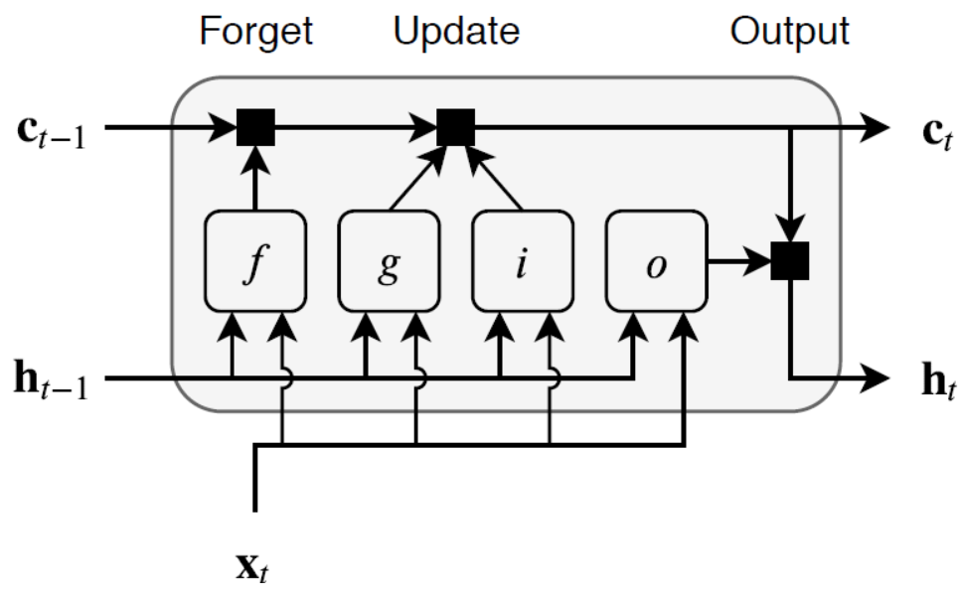

Figure 1: Long Short-Term Memory (LSTM) Cell Structure [37]

**Activation Functions**

For the single fully connected layer in this work, we used the hyperbolic tangent (tanh) activation function:

|  |  |  |
| --- | --- | --- |
|  | $$act_{tanh}\left(x\right)= tanh\left(x\right)$$ | *1* |

We also utilized the sigmoid activation function for the gates:

|  |  |  |
| --- | --- | --- |
|  | $$act_{sigmoid}\left(x\right)= sigmoid\left(x\right)$$ | ***2*** |
|  |  |  |

**Data Collection**

We collected data from the following sources:

**Elia Group Solar Photovoltaic (PV) Power Generation Data**: Historical solar PV generation data from Elia Group, a transmission system operator based in Belgium. The data is based on Belgium's historical solar PV data and is available in quarter-hour intervals. The monitored capacity of the PV generating units in the dataset is currently 4787.56 MW. The dataset, consisting of the historical power output of the monitored PV plants, can be downloaded from [38].

**Reference Dataset**: This dataset includes 21 photovoltaic facilities located throughout Germany, with generating unit capacities ranging from 0.1 to 8.5 megawatts. The installations cover a range of PV systems, from residential panels to large solar farms. The dataset contains both historical power output data and weather data. It can be downloaded from [39].

**Feature Extraction**

One of the objectives of this work is to demonstrate that by extracting the appropriate features, we can achieve accurate and reliable forecasts using historical power output data from PV plants. We extracted important features by analyzing the timestamp and identifying the components that influence the power output. A graph depicting the power output measurements at 15-minute intervals from January 2013 to December 2020 is shown in Figure 2.

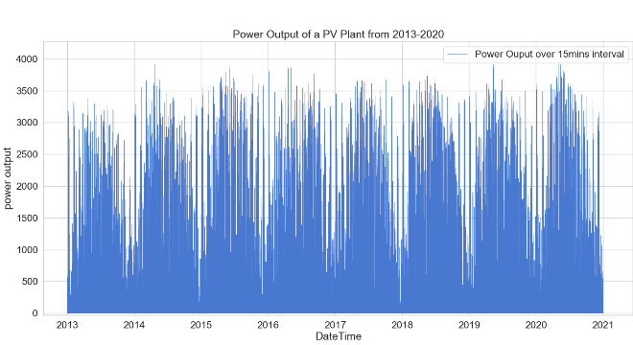

Figure 2: Power Output Measurement at 15-minute Intervals (2013-2020)

**Hourly Power Output Magnitude Aggregation:**

It is evident from Figure 3 that a regular trend can be observed, indicating that the magnitude of the power output exhibits hourly variations. The graph resembles a distribution curve, with the peak occurring around midday. This pattern is closely connected to the amount of solar radiation incident on the PV panels.

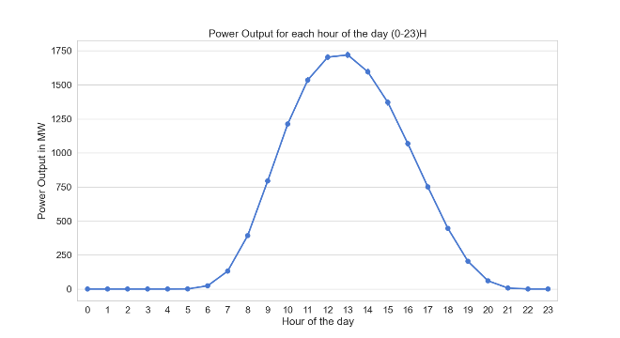

Figure 3: Hourly Magnitude of Output Power (Summed Across the Years)

**Aggregated Monthly Power Output (2013-2020)**

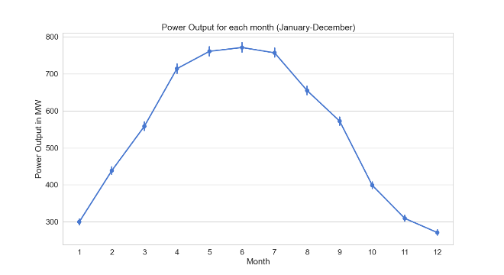

Figure 4: Total Monthly Power Output (2013-2020)

Figure 4 exhibits seasonality, indicating that the power output is higher during the summer season compared to other seasons. This seasonality is a crucial component of our forecasting, as our model will consider the season in predicting power output.

**IV. Experimental Evaluation**

This section presents an experimental evaluation to demonstrate that accurate feature extraction leads to a reliable forecast comparable to datasets that include multiple data sources, such as weather data and weather forecasts.

**1. Reference Model**

The reference technique is an LSTM model trained on the data from [39]. In contrast to the model trained on the data from [38], the reference model incorporates multiple data sources, including meteorological variables such as temperature, diffuse irradiation, and direct normal irradiation. On the other hand, our model utilizes only the historical PV power output data to train an LSTM algorithm.

**Data Description**

Our dataset consists of historical PV data from integrated PV plants in Belgium. It includes a date-time column with information on the year, month, day of the month, hour, minute, and seconds. The data is recorded at 15-minute intervals. Additionally, the dataset includes the capacity of the PV plants at each measurement point, as the capacity of the plants increases over time.

To enhance prediction accuracy, we normalize the measured values by dividing them by the capacity at the corresponding measurement point. We then multiply the normalized values by a base value, which represents the maximum capacity of the PV plants over time. Mathematically, this process can be expressed as:

|  |  |  |
| --- | --- | --- |
|  | $$corrected output=\frac{\left(measured output\right)}{capacity at the point of measurement}×base capacity$$ | 3 |

Our base capacity is the current capacity of the monitored PV plants, which is 4787.56 MW. This allows us to compare the prediction accuracy without accounting for the capacity of the PV plants.

We further normalize the corrected output power to be within the range of 0 to 1 using the maximum corrected power output of the PV plants. This normalization process is expressed as:

|  |  |  |
| --- | --- | --- |
|  | $$normalized value=\frac{corrected output}{\max{imum}corrected output}$$ | 4 |

**3. Error Measures**

We utilize four different error indices to compare the accuracy of our model with the reference model. These error measures include:

1. Root Mean Squared Error (RMSE), calculated using the equation:

|  |  |  |
| --- | --- | --- |
|  | $$normalized value=\frac{corrected output}{\max{imum}corrected output}$$ | 5 |

1. BIAS, calculated using the equation:

|  |  |  |
| --- | --- | --- |
|  | $$BIAS\left(x^{'}, x\right)=\frac{1}{N}\sum_{n=1}^{N}{\left(x_{n}^{'}-x_{n}\right)}$$ | 6 |

1. Mean Absolute Error (MAE), calculated using the equation:

|  |  |  |
| --- | --- | --- |
|  |  | 7 |

1. Average Absolute Deviation, calculated using the equation:

|  |  |  |
| --- | --- | --- |
|  |  | 8 |

Where x' represents the predicted power output, x represents the measured power output, and N represents the number of samples.

**4. Experimental Setup**

To evaluate the effectiveness of our technique, we conducted multiple experimental simulations to forecast 15 minutes ahead using the two datasets. All data cleaning, preprocessing, and feature extraction were performed using the pandas API in Python 3.9. The LSTM model was implemented using three layers: one input layer, one hidden layer with 200 neurons, and one output layer.

The training parameters of our model are summarized in Table 1. We partitioned the data into 90% for training and 10% for testing. The model was trained using the training dataset, and the errors were calculated using the testing dataset. The network with the lowest error was selected as the final model.

Table 1 Training Parameters of proposed Model

|  |  |
| --- | --- |
| Parameter | Value |
| Learning Rate Drop Period | 125 |
| Initial Learning Rate | 0.005 |
| Gradient Threshold | 1 |
| Number of Epochs | 450 |
| Learning Rate Drop Factor | 0.2 |

We trained a total of 50 LSTM models and evaluated their performance. Among these models, we selected the one that exhibited the best performance for our analysis.

For the reference model, we used the same training parameters as the proposed model. These parameters were chosen based on their performance during the training process, ensuring that the reference model is comparable to the proposed model.

**5. Experimental Results**

The error scores of our model during the experimental simulation, including RMSE, MAE, AbsDev, and BIAS, are presented in Table 2.

Table 2: Error Scores of Proposed Model and the Reference Model

|  |  |  |
| --- | --- | --- |
| Error Type | Proposed Model | The Reference Model |
| RMSE | 0.0075 | 0.0445 |
| MAE | 0.0038 | 0.0368 |
| BIAS | 5.6771e-05 | 0.2786 |
| AbsDev | 9.8781e-07 | 0.0073 |

The graph in Figure 5 illustrates the comparison between the forecasted values (red line) and the measured values (blue line). It is evident that the measured and predicted values closely align. Additionally, Figure 5 displays the difference between the predicted and measured values for each data point.

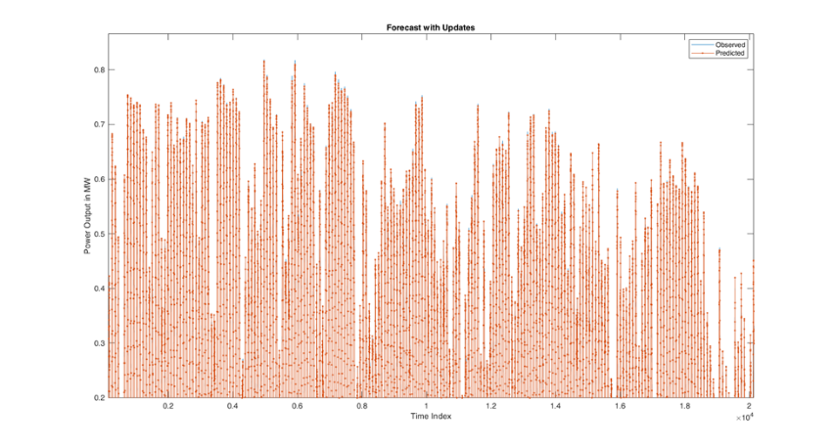

Figure 5: Comparison of Measured Values to Predicted Values

**V. Discussion**

Table 2 clearly demonstrates the superior performance of our model compared to the reference model. The RMSE of our model is approximately six times lower than that of the reference model, indicating significantly higher accuracy. Similarly, the MAE of our model is approximately 9.7 times lower than the reference model, further emphasizing its superiority. This can be attributed to the selection of the right model and appropriate feature extraction, as well as the larger size of our dataset. It is worth noting that our model's performance improves over time as more training examples become available.

The RMSE and MAE values of our model, 0.0075 and 0.0038 respectively, indicate that the RMSE is only approximately 1.97 times greater than the MAE. This small difference suggests that our forecasted values closely align with the observed values, demonstrating the high accuracy of our model.

The success of our model can be attributed to the careful selection of the algorithm suitable for the time horizon, the extraction of relevant features, and the appropriate choice of model parameters.

**VI. Conclusion and Recommendation**

In this thesis, we have successfully employed the LSTM deep learning algorithm for short-term prediction of PV output power. By utilizing only historical PV output data, we were able to achieve accurate forecasts for 15 minutes ahead.

The integration of PV plants into the grid is made possible with reliable power output forecasting. Our model has demonstrated high accuracy, even in locations with limited weather data, by utilizing the right algorithm, relevant features, and appropriate model parameters.

It is important to note that our model is specifically designed for short-term forecasting and may not perform as effectively for long-term predictions. However, by ensembling our model with another suitable deep learning algorithm, it is possible to improve the performance for long-term solar PV output power forecasting.

Furthermore, our model can be extended to forecast the output power of wind power generating units and other renewable energy sources that exhibit time-series data patterns. By applying the same principles and adapting the model to the specific characteristics of these energy sources, accurate predictions can be achieved.

In conclusion, our research has demonstrated the efficacy of the LSTM deep learning algorithm for short-term PV output power forecasting. We recommend further exploration and refinement of this model for different time horizons and other renewable energy sources.

**References**

[1] Anonymous, “Protection of the ozone layer,” Climate Action - European Commission, Nov. 23, 2016. https://ec.europa.eu/clima/policies/ozone_en (accessed Sep. 21, 2021).

[2] R. Ahmed, V. Sreeram, Y. Mishra, and M. D. Arif, “A review and evaluation of the state-of-the-art in PV solar power forecasting: Techniques and optimization,” Renewable and Sustainable Energy Reviews, vol. 124, p. 109792, May 2020.

[3] E. İzgi, A. Öztopal, B. Yerli, M. K. Kaymak, and A. D. Şahin, “Short–mid-term solar power prediction by using artificial neural networks,” Solar Energy, vol. 86, no. 2, pp. 725–733, Feb. 2012.

[4] A. S. B. Mohd Shah, H. Yokoyama, and N. Kakimoto, “High-Precision Forecasting Model of Solar Irradiance Based on Grid Point Value Data Analysis for an Efficient Photovoltaic System,” IEEE Transactions on Sustainable Energy, vol. 6, no. 2, pp. 474–481, Apr. 2015.

[5] “Climate and Earth’s Energy Budget,” Jan. 14, 2009. https://earthobservatory.nasa.gov/features/EnergyBalance (accessed Sep. 21, 2021).

[6] U. K. Das et al., “Forecasting of photovoltaic power generation and model optimization: A review,” Renewable and Sustainable Energy Reviews, vol. 81, pp. 912–928, Jan. 2018.

[7] C. W. Chow et al., “Intra-hour forecasting with a total sky imager at the UC San Diego solar energy testbed,” Solar Energy, vol. 85, no. 11, pp. 2881–2893, Nov. 2011.

[8] Z. Peng, D. Yu, D. Huang, J. Heiser, S. Yoo, and P. Kalb, “3D cloud detection and tracking system for solar forecast using multiple sky imagers,” Solar Energy, vol. 118, pp. 496–519, Aug. 2015.

[9] C. Cornaro, M. Pierro, and F. Bucci, “Master optimization process based on neural networks ensemble for 24-h solar irradiance forecast,” 2015.

[10] H. T. Pedro and C. Coimbra, “Assessment of forecasting techniques for solar power production with no exogenous inputs,” 2012.

[11] D. Yang, V. Sharma, Z. Ye, L. I. Lim, L. Zhao, and A. W. Aryaputera, “Forecasting of global horizontal irradiance by exponential smoothing, using decompositions,” Energy, vol. 81, pp. 111–119, Mar. 2015.

[12] H. T. C. Pedro and C. F. M. Coimbra, “Nearest-neighbor methodology for prediction of intra-hour global horizontal and direct normal irradiances,” Renewable Energy, vol. 80, pp. 770–782, Aug. 2015,.

[13] H. T. C. Pedro and C. F. M. Coimbra, “Short-term irradiance forecastability for various solar micro-climates,” Solar Energy, vol. 122, pp. 587–602, Dec. 2015.

[14] C. Chen, “k-Nearest Neighbor Neural Network Models for Very Short-Term Global Solar Irradiance Forecasting Based on Meteorological Data,” 2017.

[15] C. Chen, S. Duan, T. Cai, and B. Liu, “Online 24-h solar power forecasting based on weather type classification using artificial neural network,” Solar Energy, vol. 85, no. 11, pp. 2856–2870, Nov. 2011.

[16] I. Ashraf and A. Chandra, “Artificial neural network based models for forecasting electricity generation of grid connected solar PV power plant,” International Journal of Global Energy Issues, vol. 21, Feb. 2004.

[17] B. Singh, D. Shahani, and A. Verma, “Neural network controlled grid interfaced solar photovoltaic power generation,” Power Electronics, IET, vol. 7, pp. 614–626, Mar. 2014.

[18] C. Ben Salah and M. Ouali, “Comparison of fuzzy logic and neural network in maximum power point tracker for PV systems,” Electric Power Systems Research, vol. 81, no. 1, pp. 43–50, Jan. 2011.

[19] A. K. Yadav and S. S. Chandel, “Solar radiation prediction using Artificial Neural Network techniques: A review,” Renewable and Sustainable Energy Reviews, vol. 33, pp. 772–781, May 2014.

[20] E. Ogliari, F. Grimaccia, S. Leva, and M. Mussetta, “Hybrid Predictive Models for Accurate Forecasting in PV Systems,” Energies, vol. 6, pp. 1918–1929, Apr. 2013.

[21] K. Dahmani, D. Rabah, G. Notton, C. Paoli, M.-L. Nivet, and C. Voyant, “Estimation of 5-min time-step data of tilted solar global irradiation using ANN model,” Energy, Aug. 2014.

[22] C. Cortes and V. Vapnik, “Support-vector networks,” Mach Learn, vol. 20, no. 3, pp. 273–297, Sep. 1995.

[23] M. Rana, I. Koprinska, and V. G. Agelidis, “2D-interval forecasts for solar power production,” Solar Energy, vol. 122, pp. 191–203, Dec. 2015.

[24] A. Mellit, A. M. Pavan, and M. Benghanem, “Least squares support vector machine for short-term prediction of meteorological time series,” Theor Appl Climatol, vol. 111, no. 1, pp. 297–307, Jan. 2013.

[25] M. A. M. Ramli, S. Twaha, and Y. A. Al-Turki, “Investigating the performance of support vector machine and artificial neural networks in predicting solar radiation on a tilted surface: Saudi Arabia case study,” Energy Conversion and Management, vol. 105, pp. 442–452, Nov. 2015.

[26] K. Mohammadi, S. Shamshirband, W. T. Chong, M. Arif, D. Petkovic, and Dr. S. Chintalapati, “A new hybrid support vector machine–wavelet transform approach for estimation of horizontal global solar radiation,” Energy Conversion and Management, vol. 92, pp. 162–171, Mar. 2015, doi: 10.1016/j.enconman.2014.12.050.

[27] J.-L. Chen, G.-S. Li, and S.-J. Wu, “Assessing the potential of support vector machine for estimating daily solar radiation using sunshine duration,” Energy Conversion and Management, vol. 75, pp. 311–318, Nov. 2013, doi: 10.1016/j.enconman.2013.06.034.

[28] M. Q. Raza, M. Nadarajah, and A. Summerfield, “Solar output power forecast using an ensemble framework with neural predictors and Bayesian adaptive combination,” Solar Energy, vol. 166, pp. 226–241, May 2018, doi: 10.1016/j.solener.2018.03.066.

[29] Y.-K. Wu, C.-R. Chen, and H. Abdul Rahman, “A Novel Hybrid Model for Short-Term Forecasting in PV Power Generation,” International Journal of Photoenergy, vol. 2014, p. e569249, Jun. 2014, doi: 10.1155/2014/569249.

[30] X. G. Agoua, R. Girard, and G. Kariniotakis, “Short-Term Spatio-Temporal Forecasting of Photovoltaic Power Production,” IEEE Transactions on Sustainable Energy, vol. 9, no. 2, pp. 538–546, Apr. 2018, doi: 10.1109/TSTE.2017.2747765.

[31] D. Yang, P. Jirutitijaroen, and W. M. Walsh, “Hourly solar irradiance time series forecasting using cloud cover index,” Solar Energy, vol. 86, no. 12, pp. 3531–3543, Dec. 2012, doi: 10.1016/j.solener.2012.07.029.

[32] C. Yang, A. A. Thatte, and L. Xie, “Multitime-Scale Data-Driven Spatio-Temporal Forecast of Photovoltaic Generation,” IEEE Transactions on Sustainable Energy, vol. 6, no. 1, pp. 104–112, Jan. 2015, doi: 10.1109/TSTE.2014.2359974.

[33] E. Kardakos, M. Alexiadis, S. Vagropoulos, C. Simoglou, P. Biskas, and A. Bakirtzis, “Application of Time Series and Artificial Neural Network Models in Short-term Forecasting of PV Power Generation,” presented at the Proceedings of the Universities Power Engineering Conference, Sep. 2013. doi: 10.1109/UPEC.2013.6714975.

[34] C. Shuaixun, H. B. Gooi, and M. Wang, “Solar radiation forecast based on fuzzy logic and neural networks,” Renewable Energy, vol. 60, pp. 195–201, Dec. 2013, doi: 10.1016/j.renene.2013.05.011.

[35] M. AlKandari and I. Ahmad, “Solar power generation forecasting using ensemble approach based on deep learning and statistical methods,” Applied Computing and Informatics, vol. ahead-of-print, no. ahead-of-print, Jan. 2020.

[36] A. Gensler, J. Henze, B. Sick, and N. Raabe, “Deep Learning for solar power forecasting — An approach using AutoEncoder and LSTM Neural Networks,” in 2016 IEEE International Conference on Systems, Man, and Cybernetics (SMC), Oct. 2016, pp. 002858–002865.

[37] “Long short-term memory (LSTM) layer - MATLAB.” https://www.mathworks.com/help/deeplearning/ref/nnet.cnn.layer.lstmlayer.html;jsessionid=2cffeb8e87b69af53f468291c1fe#mw_d0e4b3f3-07ef-4fcf-b148-0cc24f3f613b (accessed Jul. 11, 2021).

[38] “Solar-PV power generation data.” https://www.elia.be/en/grid-data/power-generation/solar-pv-power-generation-data (accessed Jul. 10, 2021).

[39] G. Singh, Grv-Singh/Solar-Power-Forecasting. 2021. Accessed: Jul. 14, 2021. [Online]. Available: https://github.com/Grv-Singh/Solar-Power-Forecasting

[40] “pandas-dev/pandas,” GitHub. https://github.com/pandas-dev/pandas (accessed Jul. 12, 2021).

[41] “MathWorks - Makers of MATLAB and Simulink.” https://www.mathworks.com/ (accessed Jul. 12, 2021).